Catania, _______________________
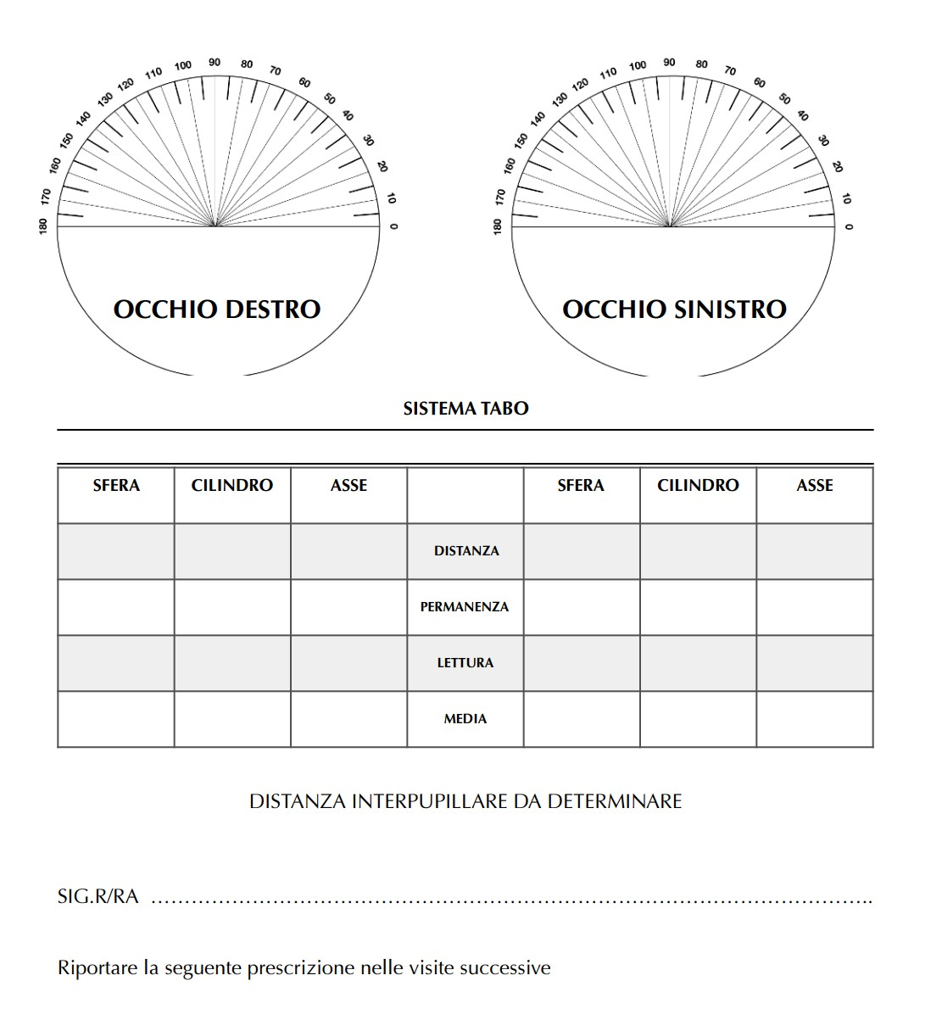

Catania, _________________

Sig.r/a _____________________________

